# Kubectl 常用命令大全

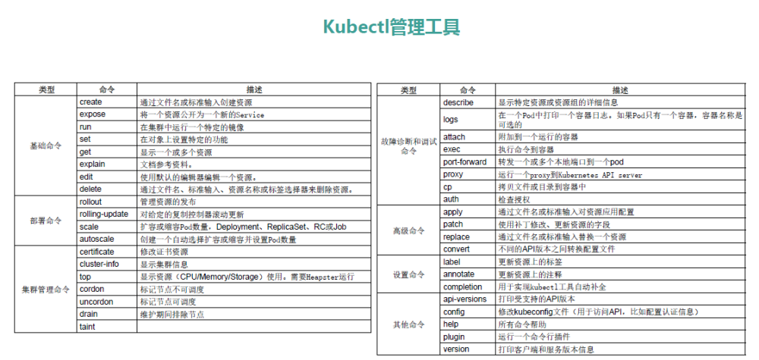

[Kubectl 常用命令大全](https://www.yp14.cn/2020/02/12/Kubectl-%E5%B8%B8%E7%94%A8%E5%91%BD%E4%BB%A4%E5%A4%A7%E5%85%A8/)